ELEC-2110

Electric Circuit Analysis

FROM: Jacob Howard

TO: Markus Kreitzer

DATE: August 21, 2019

LAB SECTION: 002

Introduction to MultiSim: DC Analysis

# Introduction

• The Objective of this lab was to learn the basic features of MultiSim. MultiSim is a circuit simulation software tool. This tool is a great way to learn circuit education in a safe environment, providing a circuit simulation without expensive tools and preventing possible damage to equipment.

# Exercise 1

* In exercise 1, we were asked to use MultiSim to find V0 and Ix in the circuit in Fig. 27. Figure 27 is below.

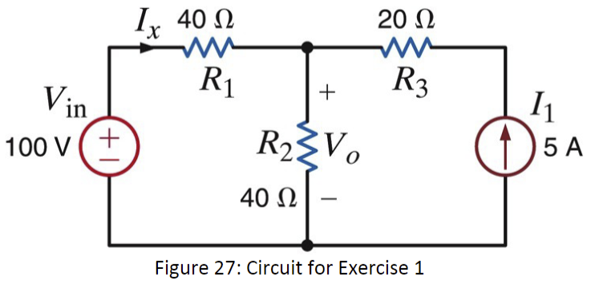

* I used Figure 27 to construct a circuit in multisim so multisim could calculate V0(Unknown Volatage) and Ix (Unknown Current). The current I constructed is below.

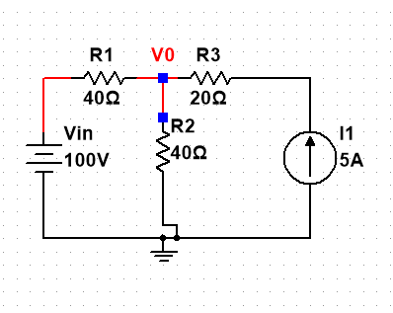

* Using the circuit I constructed in multisim I was able to calculate V0 and Ix. Found data is listed in the chart below.

|  |  |
| --- | --- |
| **V0** | 150 V |
| **Ix** | -1.25 A |

# Exercise 2

* In exercise 2, we were asked to use MultiSim to find V0 and the power supplied by the 6-V source in Fig. 28. Figure 28 is included below.

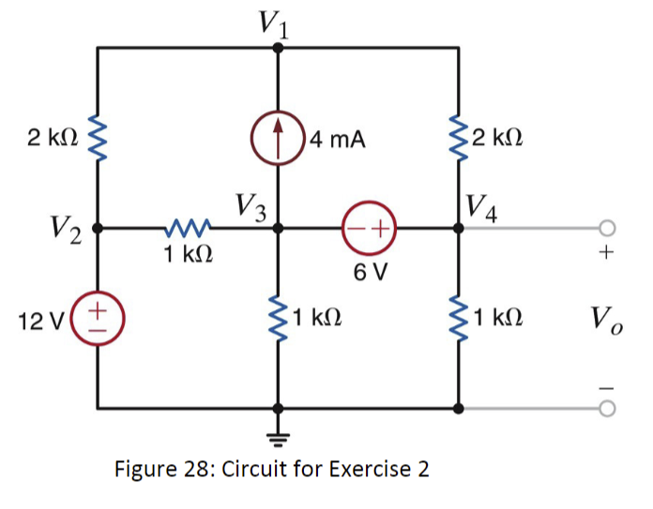

* Using figure 28, I constructed a circuit in MultiSim so I could use the software to calculate V0 and the power supplied by the 6-V source. Below, I have included the circuit I constructed in MultiSim.

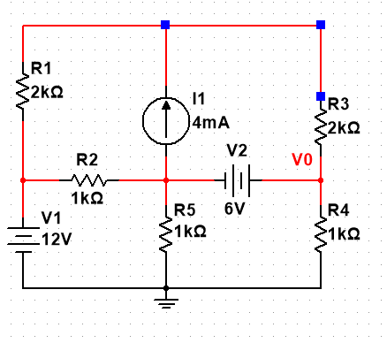

* Using the circuit I constructed in MultiSim, I was able to use the software to calculate V0 and the the power supplied by the 6-V source. The data collected is listed below.

|  |  |
| --- | --- |
| **V0** | 7.69231 V |
| **6-V Source** | 27.69231 V |

# Exercise 3

* In exercise 3, we were asked to use the dc sweep feature of MultiSim to plot V0 as the voltage Vin is varied between 50 V and 150 V in steps of 10 V in the circuit of Fig. 29. Figure 29 is listed below.

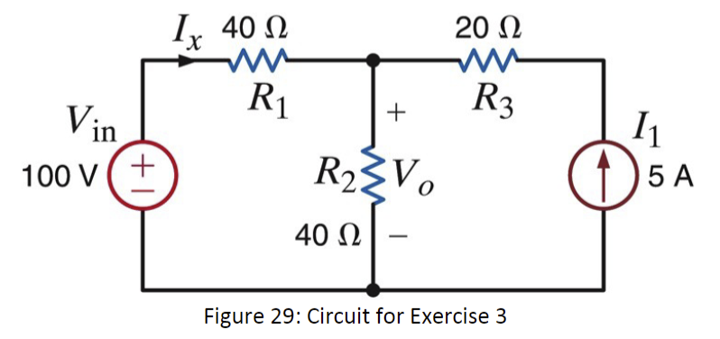

* Using Figure 29 to construct the circuit and the dc sweep feature in MultiSim, MultiSim was able to show me a graph on how the voltage and the current varies. The circuit I constructed and the graphs are below.

*Constructed Circuit*



*Voltage Vary Graph*

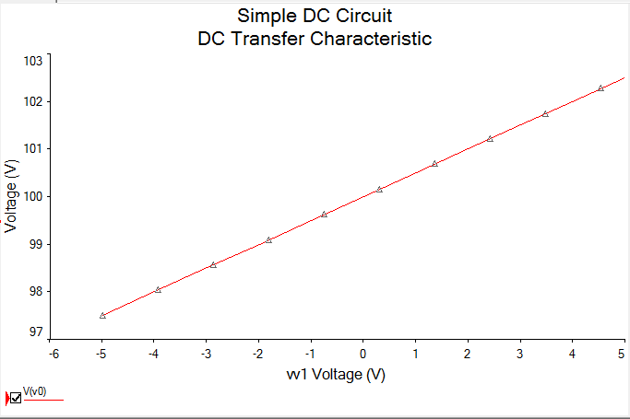

*Current Vary Graph*

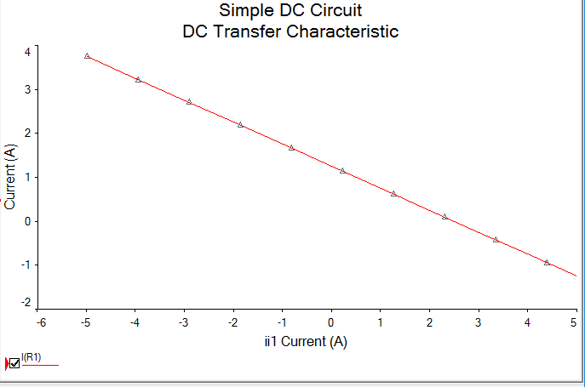

# Exercise 4

* In exercise four, we were asked to use figure 30 and MultiSim to solve for the voltage V0 as Rb varies from 250 Ω to 3 kΩ in increments of 25 Ω. Also solve for the power dissipated in Rb ( P0 ) for each value of resistance. Figure 30 is below.

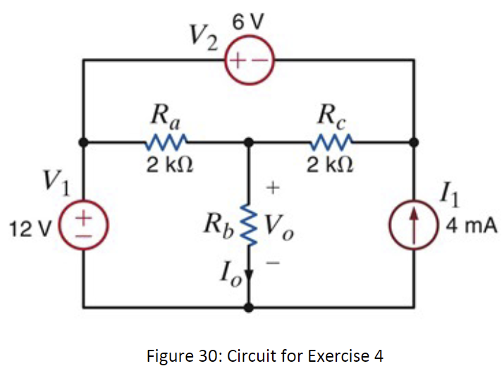

* Using figure 30 to construct a circuit, I was able to use MultiSim to display a graph for the voltage V0 as Rbvaries from 250 Ω. The circuit constructed and the graph are shown below.

*Circuit Constructed in MultiSim*

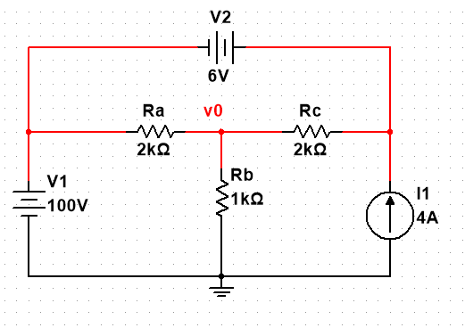

*Voltage V0 as Rb Varries Graph*

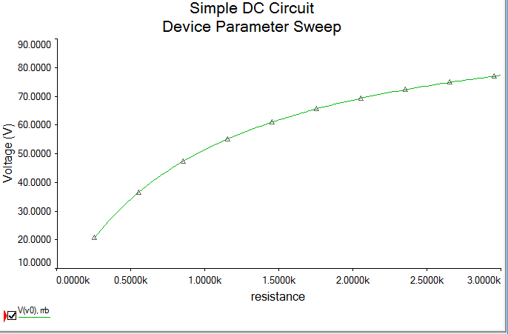

* We were also asked to find the power dissipated in Rb ( P0 ) for each value of resistance. The power dissipated is shown below in the graph given by the MultiSim software.

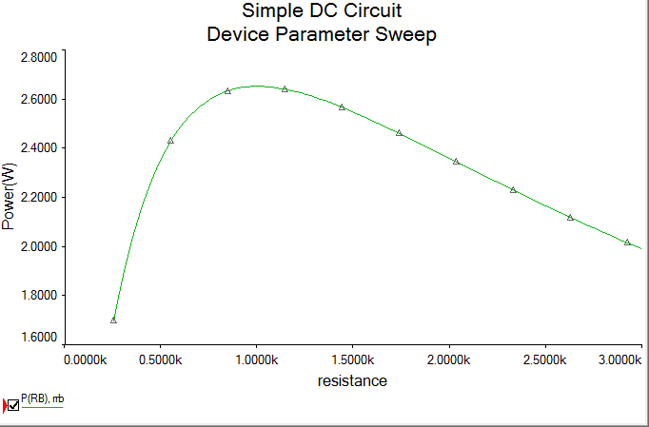

# Exercise 5

* In exercise five, we were asked to Determine I0in the circuit in Fig. 31 using MultiSim. Figure 31 is shown below

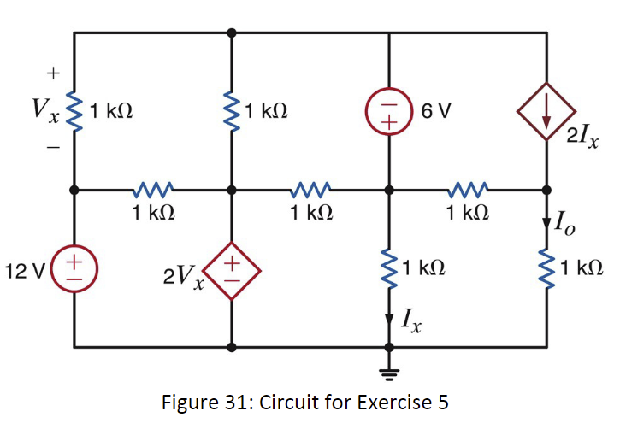

# Conclusion

Talk about anything you learned during the lab. Discuss any issues that occurred and how you resolved them. At least 3 sentences.

In this document we’ve provided you with a good foundation for working with LATEX and making quality, professional technical documentation. This is a program used by almost every organization that is serious about publishing scientific and technical research. Use of LATEX is not required for this class, but if you begin to use it regularly it will become a powerful tool to prepare you for future success.

As GTA’s, it is our hope that we can provide you with the skills and tools necessary to turn you in to competent, successful engineers. We can show you the door, but you must open it yourself. The quality of the work you produce is up to you. Best of luck and have fun! Love,

-Markus K. & Shane W.

*Bibliography If you wish to include a bibliography, edit the my bibliography file and add the following lines to your document. You can, for example, cite your Lab report [2] or something else [1]

# Bibliography

1. Freescale Semiconductor Inc. “±1.5g, ±6g Three Axis Low-g Micromachined Accelerometer”. In: (Apr. 2008). url: [https://www.sparkfun.com/datasheets/Components/General/MMA7361L.pdf.](https://www.sparkfun.com/datasheets/Components/General/MMA7361L.pdf)
2. Suraj Sindia Elizabeth Devore Bei Zhang. “EXPERIMENT 1 Introduction to MultiSim”. In: (May 2016). url: [ftp://ftp.eng.auburn.edu/pub/irwinjd/lab_manuals/Lab%201_Multisim_](ftp://ftp.eng.auburn.edu/pub/irwinjd/lab_manuals/Lab%201_Multisim_Introduction%20and%20DC%20Analysis.pdf)

[Introduction%20and%20DC%20Analysis.pdf.](ftp://ftp.eng.auburn.edu/pub/irwinjd/lab_manuals/Lab%201_Multisim_Introduction%20and%20DC%20Analysis.pdf)